Electrical Elevator

MTC Inspecting Technique and Application for Electrical Elevator Wire Rope

Hu Qiang Wan Yanying

Shanghai Qiahu Virtual Instrument Co., Ltd
October 1, 2002
MTC Inspecting Technique and Application for
Electrical Elevator Wire Rope

Hu Qiang Wan Yanying

Abstract：This article proceed from the inspecting technique for current wire rope, the main idea express the special purpose wire rope testing technique and the degree of difficulty in application. And tell every one with these. Applying the high quality enterprise with OHSAS 18000 authentication, installing advance equipment can consolidate leading in the market by themselves. Acquiring ISO9000 authentication in common enterprise just then, allocate advance equipment can enhance the rate of coverage for their own market.

Keyword：Elevator wire rope inspecting technique application

- The inspecting technique for the current wire rope
1.1 Background Condition
The wire ropes testing on line is a centennial problem at all over the world. The traditional instrument application can’t avoid to take place the missing testing and mistaken testing for that the wire ropes can be regarded as the infinite long structure complicated geometrical object. Only when the information and computer technique with the basis of the high-speed development at present, substitute software for instrument, and sample processing on the computer platform directly, can you surmount difficult technical problems. And achieve no missing, no mistaken testing on line.
In 1997，MTC Computer Magnetic Wire Rope Testing and diagnosing system came out in view of the fact that the technical train of thought successfully. The Chinese People possess the usable instrument of wire rope testing on line

1.2 Essential Principle
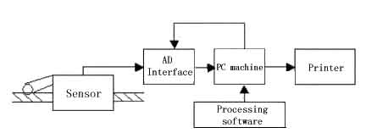

Fig.1 System Block Diagram

When the wire ropes pass through the sensor, the wire ropes are magnetized deep in the radial direction by the permanent magnet with in the senor synchronously and reach the saturation magnetization.
The leakage magnetic field of the out diffusion and the change of the magnetic flux are synchronized producing with the flaw of the broken wire, abrasion etc. The signals of the out diffusion are collected to deal with passing the AD interface. After the trans formation, the digital signals compressed input the PC machine.
In view of the fact is that the software of the three-dimensions mathematical model decompresses processing timely. In order to show the wire ropes are broken, corroded, abraded from both inside and outside, display the changes of the metallic cross-sectional area with clear and definite quantitative numerical value.

1.3 Technique Crux
The flaw of the broken wire and corrosion in the wire ropes would produce the leakage magnetic field of the out leakage. The strong and weak leakage magnetic signal of space distribution would be focused and homogenized and led to the testing circulating way that all round directions arrange the array composite Hall device by annular magnetic focus apparatus. The international is the local flaw testing method by name. The local flaw (LF) can be quantitatively measured.
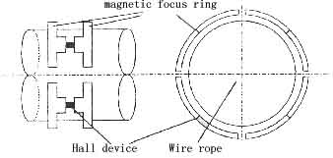

Fig.2 LF Magnetic focus Principle

The magnetic flux change of magnetic bridge way created by the metallic cross-sectional area change out of order for the balance of magnetic bridge way from location along the wire rope, such as corrosion, abrasion spots will be received even very small change due to putting the Hall on the balance point of magnetic bridge. The international is the loss testing method of metallic cross-sectional area by name. The loss of metallic cross-sectional area (LMA) can be quantitatively measured.
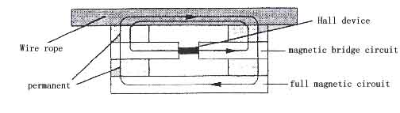

Fig.3 LMA Magnetic bridge circuit

MTC testing method based on model considers testing to process and testing instrument to be system. According to the designated importation of tested object and the testing instrument itself (namely, fore experience knowledge) and the data gained with many experiments (namely, later experience knowledge) self-particular mathematical model of testing instrument setup. Through data processing with relative calculus, it may get accurate overall descriptor on the testing results of the tested object.

2. The available bases and existing problems for electrical elevator testing wire rope
2.1 Bases
According to “The safety Norm for the Electrical Elevator Manufacture and Assemblage” (State standard GB7588)
Shanghai formulate the local standard for “The safety Norm for the Electrical Elevator Maintenance” (OB31/193) specially:
Reporting as unserviceable stipulation for electrical elevator wire rope.
- The wire rope arise from broken ply;
- The active diameter that created by the abrasion loss or corrosion of single wire in the wire rope is 90% of the original diameter at that time.;
- It is stipulated that a hank of span length for wire rope (namely, a pitch) attain the following form broken wire number at that time.；
Reporting as unserviceable single wire broken wire number form
Wire rope assurance coefficient  n | When it is within a pitch existing following broken wire rope number the wire rope must be discarded as useless promptly
Wire rope assurance coefficient  n | The abrasion loss or corrosion of wire rope surface attain the percentage (%) of the original wire rope diameter
Wire rope assurance coefficient  n | 0 | 10% | 15% | 20% | 25 | 30%
0—10 | 16 | 13 | 12 | 11 | 9 | 8
10—12 | 18 | 15 | 13 | 12 | 10 | 9
12—14 | 20 | 17 | 15 | 14 | 12 | 10
14—16 | 22 | 18 | 16 | 15 | 13 | 11
Annotation：The broken wire number in the form, reporting as unserviceable wire ropes are based on Lange lay wire rope with 1/2 mathematical value
Detecting Period for electrical elevator wire rope：
- After the electrical elevator throw into operation normally.
- Special Testing：The electrical elevator for new installation, major overhaul, important refit ment or Accident Restoration precedes safety inspection before throwing into operation.
- Maintenance Testing：The wire roper of speed governor in the mine way, compensating wire rope reconditions once every three mouths.
The electrical elevator operat the whole course with reconditioning speed in machine room. Examine wire rope passing round the whole course on the drag wheel care fully. If it exists broken wire abrasion loss, it would reference reporting as unserviceable standard processing for the wire rope

2.2 Problems
The testing for the electrical elevator wire rope can only use the traditional methods, which the people watch with their own eyes, feel by hand and measure on ruler without passable available instrument for many years. A long long multistoried wire rope of electrical elevator is tired with depending on. Visualization. And the testing is easy to miss. As for a broken wire in internal wire rope, the visualization can’t be discovered absolutely.
The Chinese high buildings get more and more. There are near 40,000 electrical elevators in Shanghai. Shanghai Mitsubishi elevator Company that pay the closest attention to the quality and the safety for electrical elevator take the lead in importing the 3 suites of elevator wire rope safety testing from Japan. Because of the expensive price of the instrument, only use this instrument on such as electrical elevator of JinMao (namely Golden Trade) buildings. And the testing results can only be qualitative, can’t be quantitative. Whether the missing testing or not can’t judge. The cop perish guide bush in the sensor is still quite thin, is easy to abrade loss. The price of the spare parts is still even more expensive.

3.The difficult point and solution of the wire rope testing for electrical elevator
3.1 The technical difficult points
The optimum location of the wire rope testing for electrical elevator is nearby the dragger in machine room of elevator standard stipulation. But the wire ropes for electrical elevator are composed arrangement of the non-independent from 4 to 6 pieces of the wire ropes. The mutual inter space is only 5~7vmm. It is unable to set the technique passing barriers, and current sensor in MTC wire rope testing. It is because the wire rope arranges densely that is more difficult. When the first piece of wire is tested, the second adjacent flaw signal would be parasitized on the first piece of wire. And the signal of interference noise is also very large. It is unable to acquire the accurate flaw of the first piece of the wire rope testing on line.

3.2 Solving Scheme
a Constructing compound Exciter circuit

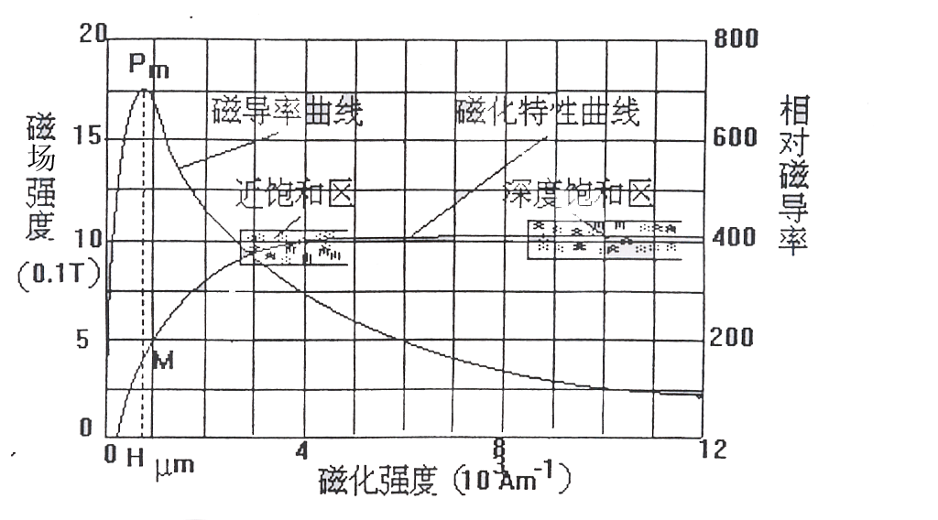

Fig.4 Magnetizing characteristic curve for wire rope

Independent single piece of wire rope testing can acquire the satisfactory results with choosing the permanent magnets of the proper number, utilizing the fork form pole terminal, according to the structure of the wire rope, or adopting single of multi circuit excitation in the radial direction. As shown Fig 4. With regard to 6×19 round strand wire rope of structure, at that time, the intensity of magnetization for the wire rope is 3-4×10³ A/M. So long as you try to make it at the moment when the wire rope passing through the sensor to attain the magnetizing approaching saturated zone, you can get the satisfactory result. According to experience we know the permanent magnets in the sensor would provide enough intensity exciting field and can make the intercity of magnetization attaining 4~5×10³ A/M concentrically in the wire rope testing for electrical elevator. There fore, adopt magnets paralleling, circumference equal distribution, multipoint polar pillar installation, thus form compound exciting, circuit. The polar pillar arrangement of magnets must be avoided, the closing of magnetic line, interfere and other slight effect, for the vector-orient ability and non-linearity.

b．Constructing magnetic shielding can conform the diffuse magnetic field near the wire rope.
After the intensity of magnetization in wire rope measured acquire the focus, the another wire rope would still be synchronized magnetization by the diffuse magnetic field for the sensor right next another wire rope. There fore we adopt the functional high permeability materials to construct magnetic shielding on the surface of the sensor. Resist the magnetic line entering non-working areas.
4. MTC the application for the electrical elevator wire rope testing and diagnosing system
4..1 The structure of sensor
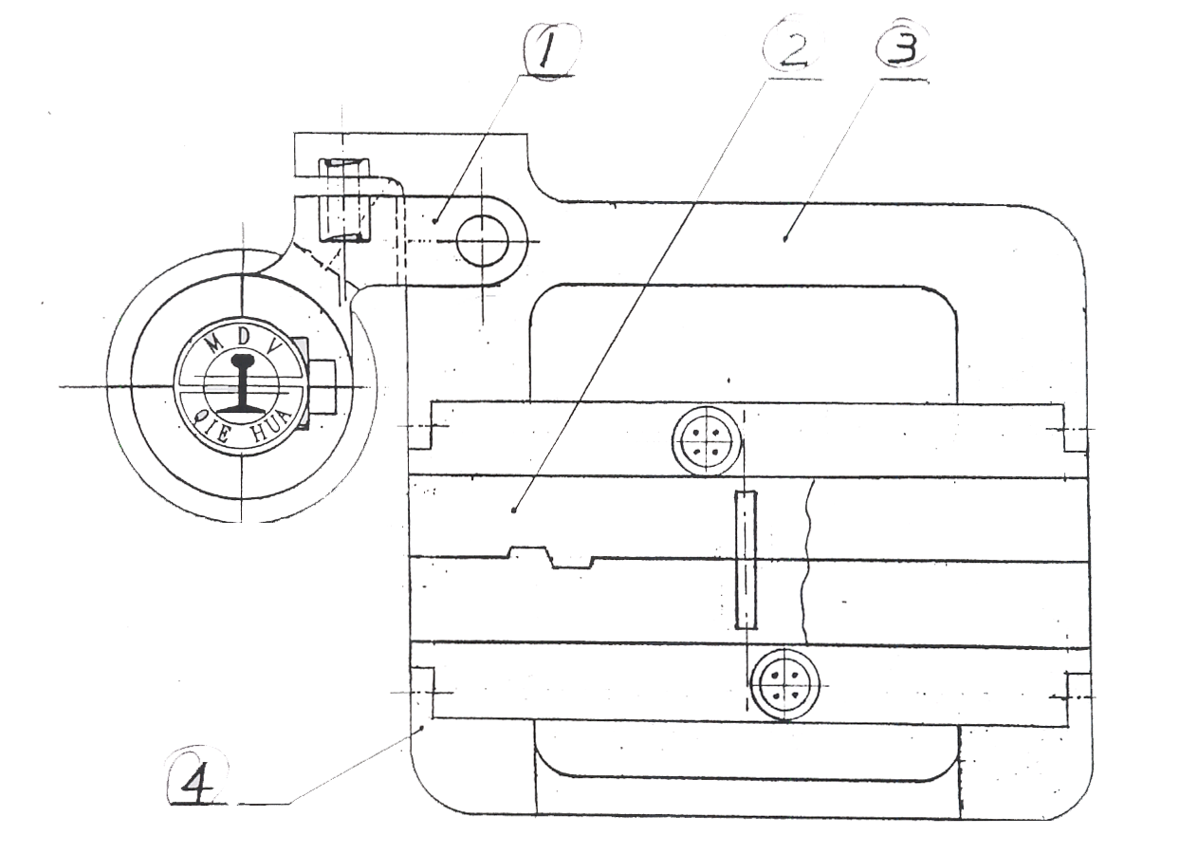

Fig.5 sensor structure diagram

As shown Fig.5, ① Location Encoder ②Sensor mandrel ③Main Fixed Support ④Sub-fixed support According to the different diameter wire rope measured for electrical elevator, can change ②the sensor mandrel for attaining accurate qualitative quantitative testing results. If the dragger circumstance location in elevator machine room is limited, use the upper part of the half sensor can acquire the same satisfactory results. But the accurate rate of the broken wire quantitative testing would decrease about5%.

4.2 Working in site
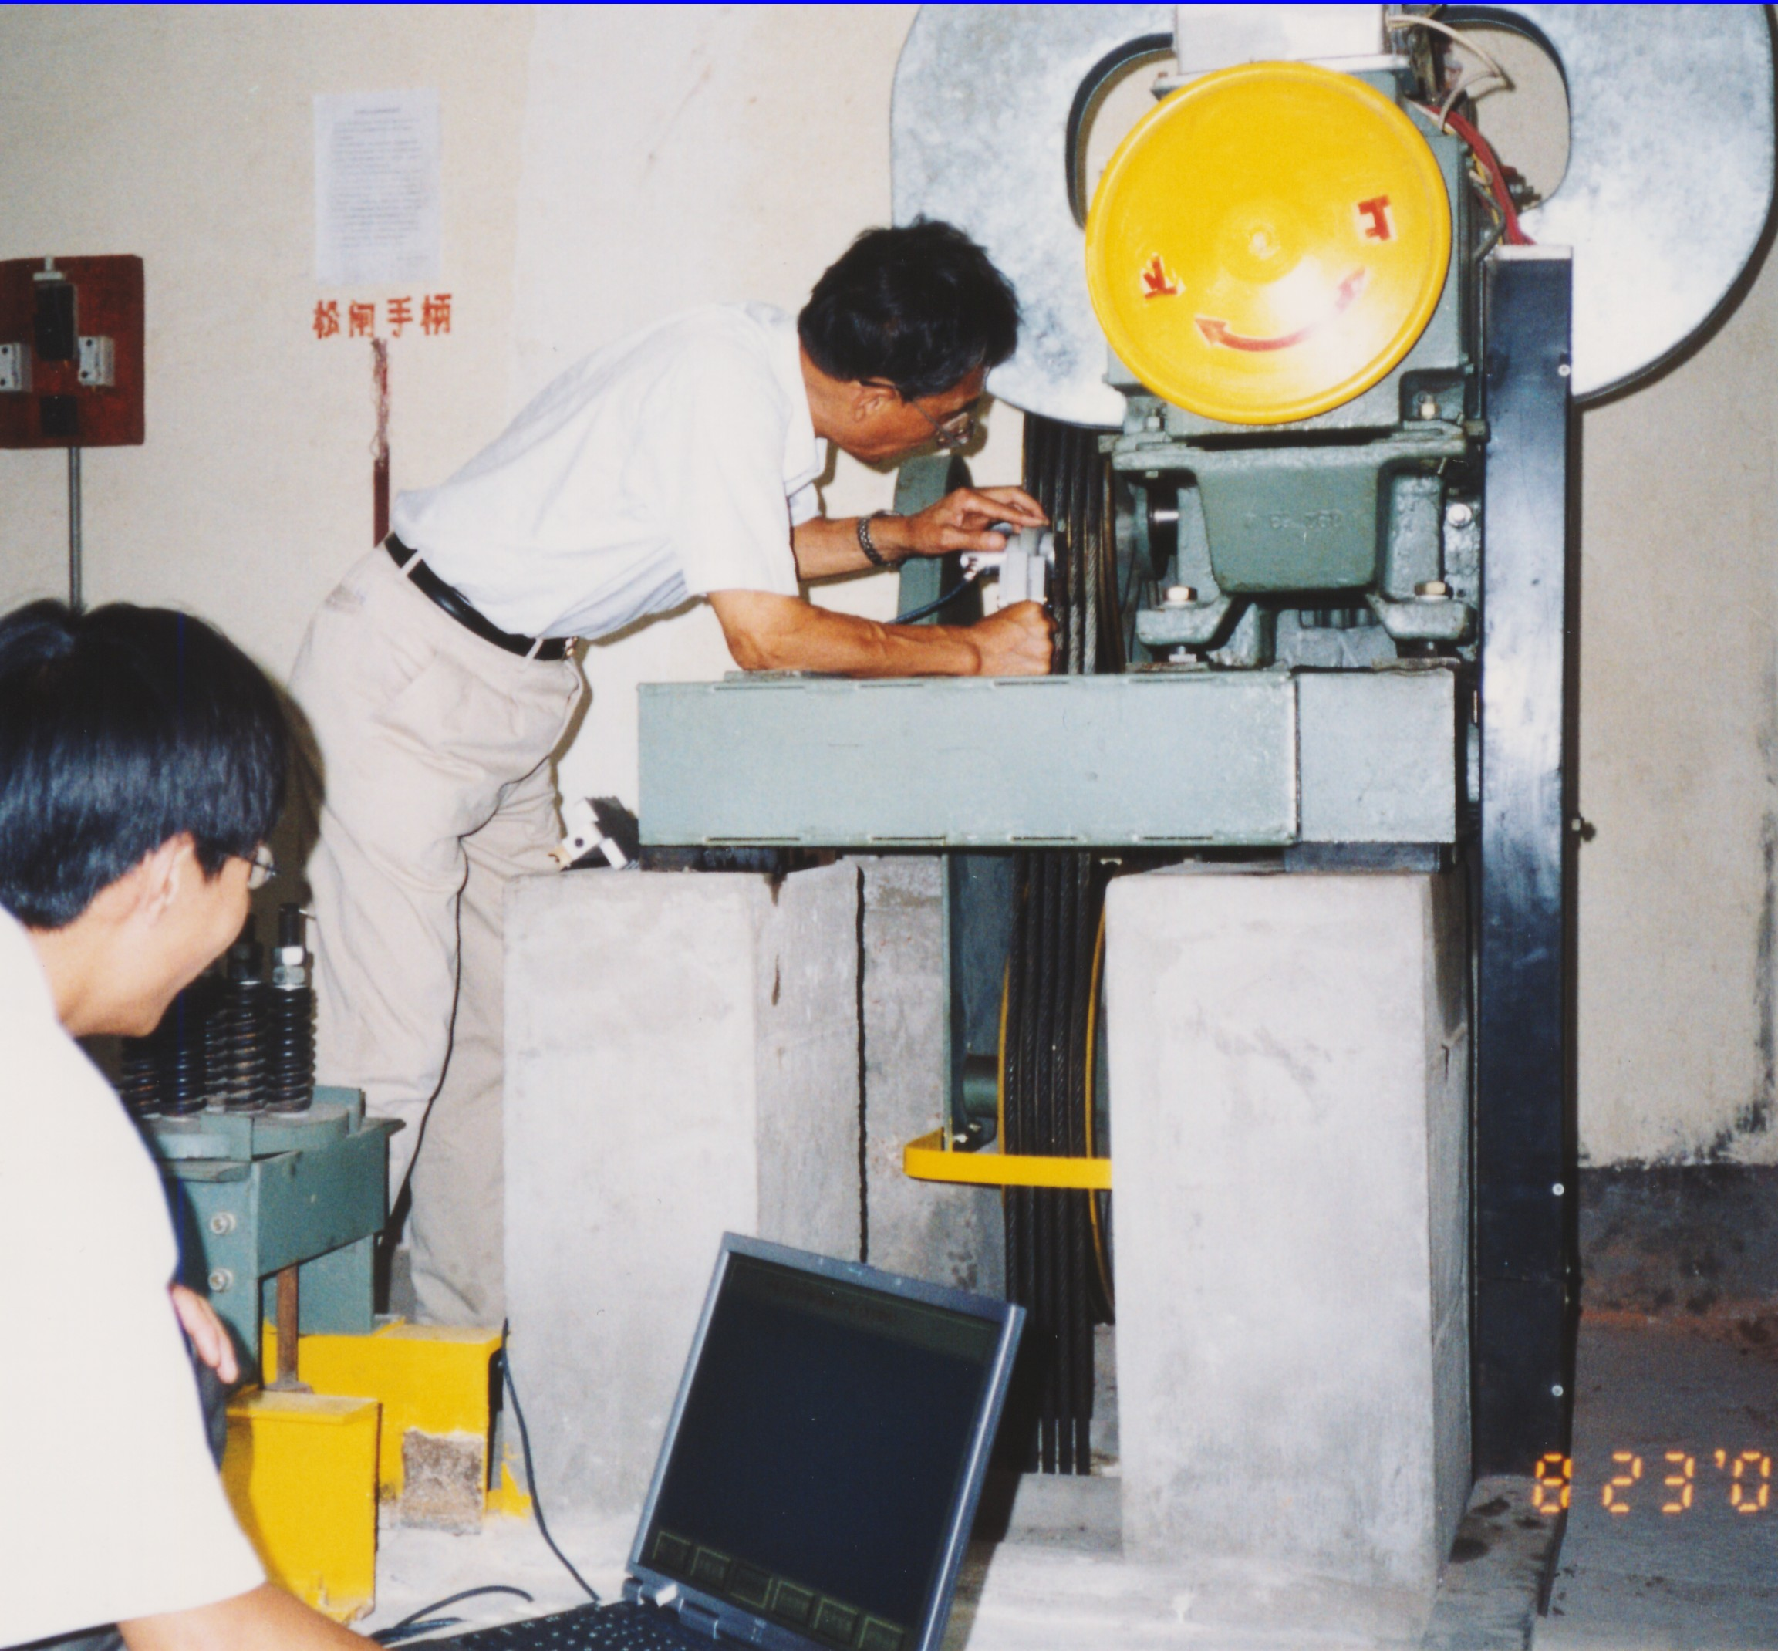

Fig.6 Elevator wire rope testing worksite
As shown Fig.6, all we need do is two inspectors, and can achieve the whole work in the dragger machine room promptly. One of them hold the sensor in his hand, the other operate the computer sampling, bear responsibility for the initiation and stop of electrical elevator wire rope and take notice of worksite safety.

4.3 Computer software
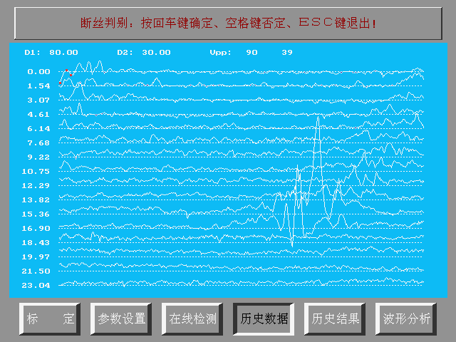

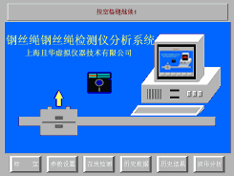
So long as you can operate the TV, on the basis of the interface prompting can conduct operation. To calibrate only once for every type wire ropes can transfer under a unified plan for a long time.
In this interface, you can confirm broken wire accurate quantity of the wire ropes and the flaw of the corrosion, loose ply, trans shape, material quality changes etc.

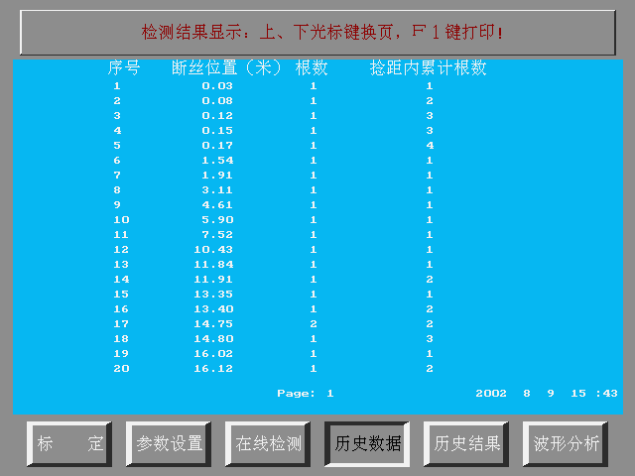
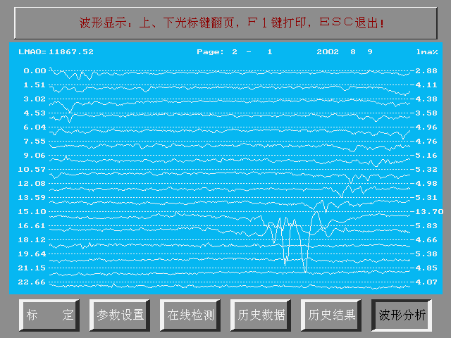

To show the broken wire location of the wire ropes, quantity and according to the broken wire quantity with in the length of lay pitch of the state current standard stipulation directly.
The data of the right column show the percentage numerical value of the change of the metallic cross-sectional area in the wire ropes. The waves show the manufacturing quality and other flaw.

5. The Application Direction Discussion for Electrical Elevator
Because of the technique and idea lagging, the elevator wire rope testing has taken over the traditional methods of artificial visualization. With the development of technique and the progress of the people’s idea, every enterprise authenticates from quality management ISO9000 and environmental management 14000 to professional safe health OHSAS18000. Management begin (and even more some of them have stipulated) stipulate that the wire rope testing must apply scientific instrument. Up-to-date Ordeas Gen2 Elevator form plastics and steel composite belt promotion out of 12 pieces of wire ropes. It should be said. It is no problems for safety absolutely. But every elevator without exception dispose the safty testing instrument of a suite of plastics and steel composite belt for the wire rope core. Thus it can be seen magnificent prospects in the application and popularization respect for MTC elevator wire ropes testing instrument.
Elevator supply and Maintenance: Advance notability enterprises can heighten qualitative grade. Backward notability enterprises can expand the occupation ratio of the market.
Architectural Real Estate Management: Relieve having anxiety over possible danger from behind of proprietors and passengers. Alleviate their psychological burden when the passengers take the.

Reference Literature：
1.Dong Xinhua Kang Yihua “Quantitative Inspection technique on line for the wire ropes” 1999
2.Shanghai Labour and social Security Bureau “Supervisory Document Compilation for Labour Protection” 1997—1999
3.Ordeas elevator Company “Innovation Science and Technique for Architectural Trade” 2000

